Parent Procedure(s): | - CMS/314 OHS Injury Management Policy

1. INTRODUCTION

The OH&S Act 2004 requires that risks associated with hazards are to be eliminated or reduced where ‘reasonably practicable.
Sewer manholes vary in depth from approx 1 metre to 15 metres depending on the design of the reticulation system and topography and are generally of reinforced concrete construction. Access is generally by means of a small opening approx ¾ - 1 metre and step irons provide access to bottom of the well. Sewer mains generally run through the bottom of the well in the form of a channel. There may also be “internal drops” where a sewer inlet is cut into the wall of the well allowing flow of sewage downstream.

GWMWater Service Delivery employees routinely work around sewer manholes in carrying out a range of inspection and maintenance duties including sewer-jetting cleaning from the surface above the manhole.

In the development and implementation of this procedure, GWMWater aim to comply with the requirements of the OHS Regulations 2017 Part 3.3 Prevention of Falls.

2. PURPOSE

The purpose of this document is to:
- Outline the fall prevention safety strategy to be undertaken by all GWMWater employees when working near a manhole
- Provide guidance on process to protect workers from Biological waste exposure hazards

3. SCOPE

This work instruction applies to all GWMWater Manholes

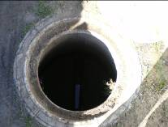 Typical Manhole
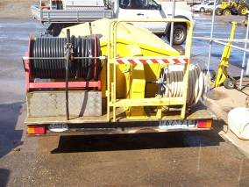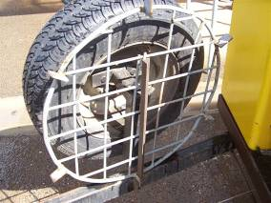

Sewer manhole barricade and manhole cover attached to sewer jetting trailer

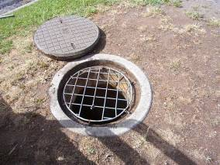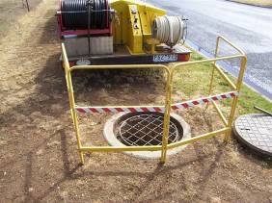

Sewer manhole prevention of falls - Manhole cover and barricade

- SEWER MANHOLE PREVENTION OF FALLS AND CLEANING WORK INSTRUCTION

Setting Up
  - Complete Safe Work Method Statement (SWMS) - CMS/1569 Safe Work Method Statement ( SWMS ) for High Risk Construction Works
  - Erect Telstra type barricade at manhole
  - Workers wear suitable PPE (Disposable gloves & Eye protection)
  - Gum boots required to be worn if attending sewer spills
  - Remove manhole lid with appropriate lid tool
  - Place manhole cover in manhole
  - Ensure manhole cover is fitted appropriately to ensure a person cannot fall into manhole
  - Complete Sewer jetting works as per procedure - CMS/3587 Operation of High Pressure Sewer Jetting Equipment – Safe Work Instruction

Pack Up
- Remove all equipment from manhole and pack up all equipment
- Remove barricade from manhole area and store appropriately
- Remove manhole cover
- Immediately replace Permanent Manhole cover
- Workers to clean tools, PPE and equipment used, by washing with low pressure water and wiped with disposable cloth to dry, before spraying with disinfectant and storing away.
- Disposable cloths, gloves are placed into a suitably labelled container and covered with a lid.
- Waste materials container is transported to appropriate disposal location and disposed of.
- Workers are to wash hands thoroughly using soap and water before drying with paper towel or if no water and soap available, then use antibacterial hand soap on clean hands only
- Report any damaged or poor fitting manhole covers to supervisor

5. REFERERENCES

  - Occupational Health and Safety Act 2004 (Vic) s21 Duties of Employers to Employees
  - Occupational Health and Safety Regulations 2017 (Vic) Part 3.3 Prevention of Falls
  - R2021-39660 Generic prevention of falls risk assessment - Manhole & Sewer pits October 2021
  - Worksafe Victoria Prevention of falls in General Construction Compliance code
  - Sewer jetting SWI - CMS/3587 Operation of High Pressure Sewer Jetting Equipment – Safe Work Instruction
  - CMS/1569 Safe Work Method Statement (SWMS) for High Risk Construction Works
  - CMS/374 Wastewater Safe Work Instructions
  - CMS/3293 Sewer Blockages in Jump Ups Procedure
  - CMS/2021 Sewer Pump Blockage Clearing Work Instruction

