The following checklist is a step-by-step approach to setting up your workstation when you as employees are located at a new workstation or whenever your tasks are changed.

It is important to give yourself a chance to get used to any changes that have occurred, as it may take several hours or even days to determine the best operating position. Remember it may take several tries to get the best arrangement for yourself, but it is worth the effort and if a change doesn't work, you can always reset it back to the previous position.

CHAIR

Remember to try and avoid sitting in the same position for long periods at a time. Some form of break from sitting every 30 minutes is helpful. Even getting up for 20 to 30 seconds to go to a printer or standing while talking on the telephone will provide some relief.

1. Seat

Height.

- Your seat height should be adjusted to your individual needs to ensure that your arms are positioned correctly.
- Forearms should be slightly sloping downwards towards the keyboard. Elbows should be at least 90deg. Keep your elbows close by your side.
- The angle of your knees should be at least 90deg, to ensure that your thighs are not compressed.
- Feet are to be positioned flat, slightly apart & supported on the floor. If your feet are not well supported by the floor, use a footrest.
- Your shoulders should be relaxed at all times.
Tilt (if available).
- Set to horizontal initially, although you may wish to adjust the tilt slightly forward to suit your comfort.

2. Back support
Height.
- Start by raising the backrest to its maximum height. (If unsure of how to raise and lower the backrest, contact OH&S Officer)
- Then sit in the chair and check the fit of the backrest to the curve of the lower back. If not comfortable, lower the height by several centimetres until the curve is at the waistline.
- Ensure your buttock is positioned at the back of the seat.

Forward/backward position
- Adjust the position of the backrest until a comfortable pressure is exerted on the low back area while seated in the usual working posture at the desk.
- The backrest position should not feel as though it pushes you out of the seat or that you have to lean back too far to reach it.

DESK

3. Height

If you have a sit / stand workstation;

- The workstation can be raised or lowered to allow access to all items on your desk.
- The workstation needs to be raised to a height that is required to be able to comfortably stand.
- When in the standing position, your forearms should be slightly sloping downwards towards the keyboard. Elbows should be at least 90deg. Keep your elbows close to your side.
- To minimise leg fatigue, alternate or shift weight from leg to leg occasionally.
- Alternate between sitting and standing throughout the day to achieve the full benefits of having a sit/stand workstation.
- Limit standing position to 20 minutes.

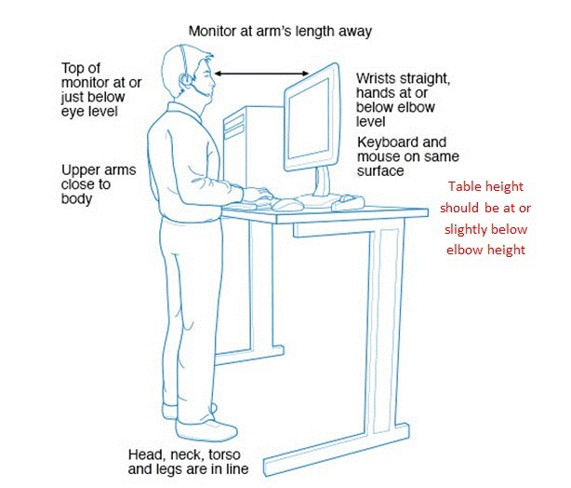

4. Clearance under the desk

- Ensure the area under the desk is clear. Items, such as boxes of documents or rubbish bins may force the person to adopt a twisted or awkward posture of' the spine.

5. General storage on the desk

- In trays. Place in-trays at the Outer Reach Sector. See Figure 6. In-trays should not be located above shoulder level.

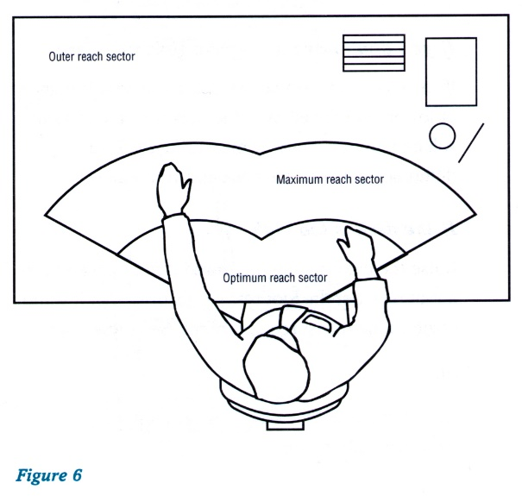
6. Reference books and folders.

- Large or heavy references should be stored where the user does not have to reach above shoulder level either seated or standing. This can result in undue strain on the back, shoulder and arm muscles.

- Place more commonly used folders closer to the user and lighter or lesser used folders further away and access them by standing up to reach.

7. Keyboard

Angle
- The common and preferred setting is where the feet are lowered so the keyboard sits flat on the desk.

Position on the desk
- Place the keyboard as close to the front edge of the desk as is comfortable. Do not place documents between the keyboard and the front edge of the desk while using the keyboard.

8. Mouse

If you frequently use the mouse in your work, you may wish to:
- Learn to use it with both hands so that you can swap between the right and left side for improved comfort
- Maintain your mouse to keep it in good working order (for example, keeping it clean inside)
- If using a mouse, keep it close to your body to avoid reaching.

9. Telephone

- Place at the limit of the Optimum Reach Sector.
- When making a lot of calls, it is best to place the telephone on the same side as the dominant hand.
- When mostly receiving calls, it may be more comfortable to place it on the non-dominant side.
- Use a phone headset if you need to use the computer while talking on the phone. This will help avoid shoulder and neck strain.

COMPUTER SCREEN
The screen should be positioned once the chair and desk heights have been established.

10. Height

- The screen should be positioned so that the top of the screen is level with, or slightly lower than your eyes.

If your desk does not have an adjustable arm or the arm cannot be adjusted appropriately, you can use telephone books temporarily to raise the screen height and then contact the OH&S Officer who can then arrange for a more permanent device to be provided.

11. Distance from the eye

- Place the screen so that it is approximately an arm's length away from the usual seated position of the user.

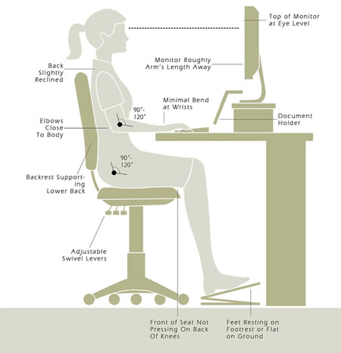

12. Positioning the screen

- The screen should be placed in front of the user to avoid glare or reflections from windows. It should also be tilted to prevent reflections from overhead lights and windows.
- To reduce stress on the neck when working from paper documents, a document holder can be placed between the keyboard and the monitor.

A laptop should not be used on the desktop for permanent or extended use. Alternative options include;
- Placing the laptop into a docking station.
- Connecting into existing computer equipment, such as a keyboard and screen.
- Transferring information from the laptop to the desktop computer for extended periods of work.
- Use a laptop stand to achieve appropriate height.
- If using a laptop, you should always use a separate keyboard.
- Dual screens should be set up side by side with the screens slightly angled towards each other. When shifting focus from one screen to another, ensure you twist your chair rather than your torso.

13. Keep moving
- Remember to take breaks from your desk regularly, preferably every 45 minutes to an hour for 1-2 minutes at a time.

For more information phone or speak to the OH&S Officers, HSR or your Manager.

